**Library Management System ( L . M . S ) .**

As the name suggest the Library Management System is a software which handles the entire data of library. It makes the work of librarian very easy instead of writing data in a notebook. In past the librarians were using notebooks to write the data of books along with student’s name who borrowed that book. So it was very difficult to keep track on each and every book.

If librarian wants to search for a particular book, then that task was very time consuming. So to make this task easy the programming languages were developed and C++ language is one of them.

1. **Introduction:**

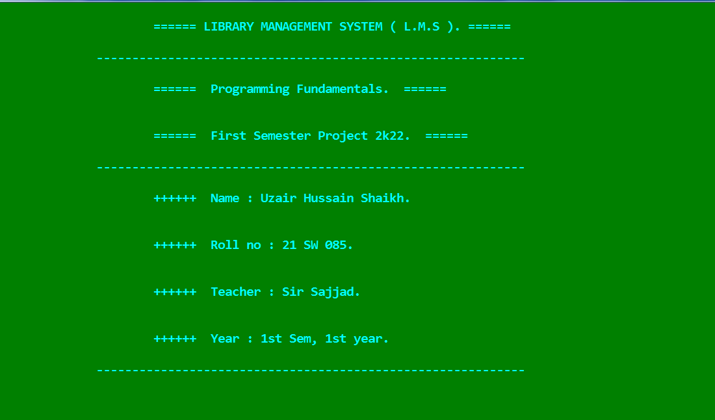

1. **Login Interface ( i ):**

If you select student option to login it will not require any password you have direct access to student features of l.m.s.

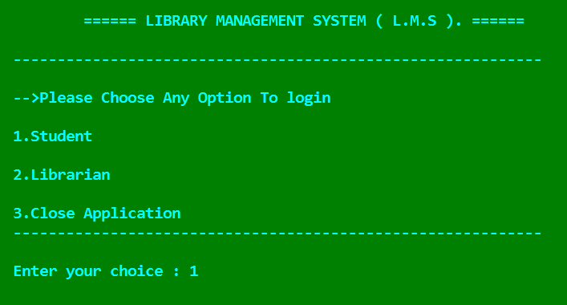

1. **Login Interface ( ii ):**

If you select librarian option to login it will require password “admin123”, and then tou have access to librarian features of this management system.

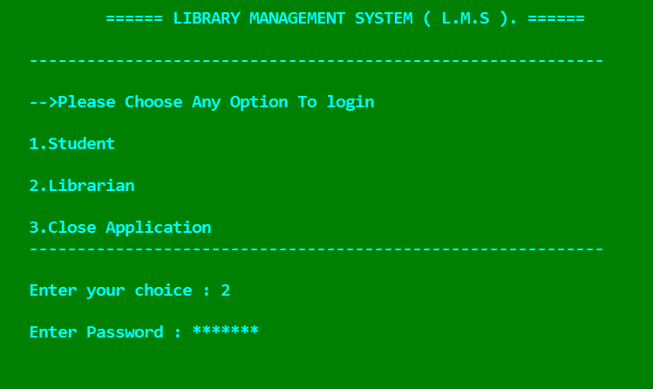

1. **Student:**

The student will not require additional sign in, he or she will be able to access the software directly.

When the student enters the choice as 1 then following screen will be appeared:

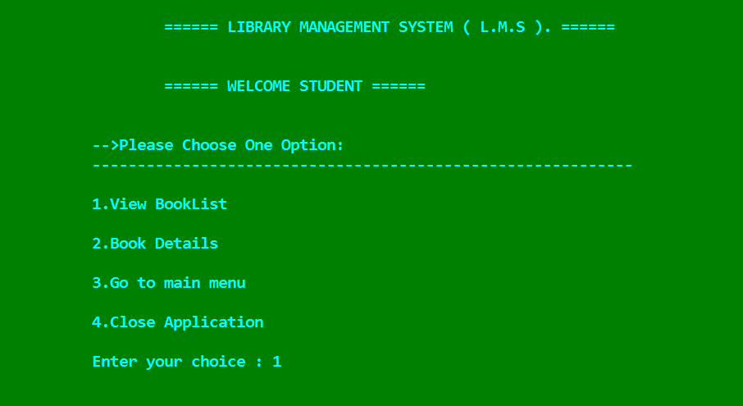

1. **Librarian:**

To access the features of the librarian menu, He/she will require to sign in using the password which is “**admin123**“.

When the user presses the choice as 2. then the software will ask you to enter the correct password as shown in the following image:

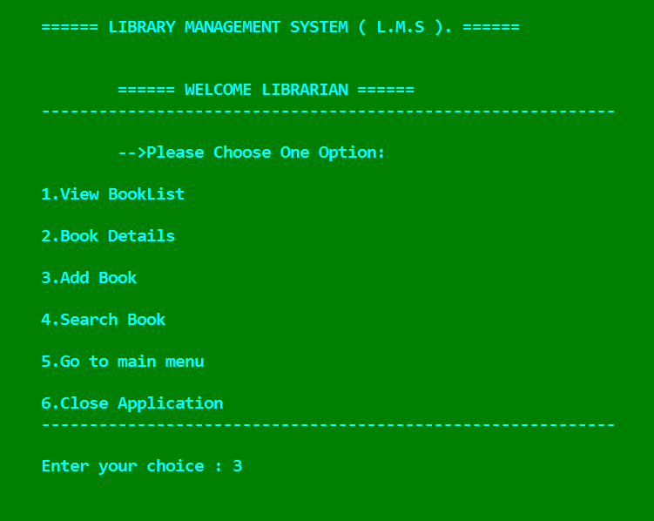

1. **Exit:**

If you select option 6 (Close application ) then this means you are coming out of your program/software after visiting it.

